Honorary Swiss Solar Prize
for Lord Norman Foster

Lord Norman Foster’s architectural masterpieces such as the Reichstag in Berlin, the «Gherkin» in London, the Millau viaduct in France, the international airport of Beijing or the Chesa Futura in St. Moritz with its optimal building insulation of 50 cm are all perfect examples for brilliant design, sustainable architecture and future-oriented urban planning. Lord Foster’s outstanding buildings and infrastructure projects are sustainable landmarks shaping the skylines of modern cities on six continents. Evidently, he was therefore the perfect patron for the Swiss Solar Award and the ideal architect to initiate a new era of solar architecture in 2010. With the Norman Foster Solar Award for an aesthetically exemplary PlusEnergyBuilding solar architecture, Lord Foster laid the foundation to change the whole energy supply in the building and traffic sector to renewable and CO2-free energies. For this achievement Lord Foster obtains the Honorary Solar Prize 2015.

Lord Norman Foster, Foster + Partners, London/GB

Lord Foster’s oeuvre includes a large num- ber of buildings that distinguish themselves in a perfect combination of technology, aes- thetics and functionality. His buildings are characterized by an incomparable beauty that captures and fascinates the viewer.They are uncompromisingly modern while still re- specting the past; they fit harmoniously into the environment but stand out at the same time. These typical characteristics were at- tested to the Reichstag of Berlin by Dr. Wolf- gang Thierse, former president of the Ger- man Federal Parliament.
Lord Foster and his practice Foster + Partners have received almost 700 awards since it was founded in 1967, including all important architecture and sustainability awards worldwide. He was also appointed to the British House of Lords.
With the Norman Foster Solar Awards for aesthetically outstanding PlusEnergyBuil- dings (PEB), Lord Foster initiated a new era of solar architecture in cooperation with the Solar Agency in 2010. On the annual ave- rage, Lord Foster’s aesthetically exemplary PEB produce more energy than they need, and energy-intensive buildings therefore be- long to the past.
In the long term, an intelligent solar ar- chitecture with Lord Foster’s new PEB and with PEB refurbishments will enable us to replace the whole fossil-nuclear energy sup- ply by solar and other renewable energies. It is a privilege and an invaluable opportunity to co-operate with Lord Foster in order to advance sustainable solar architecture. We feel honoured to present him with the Hono- rary Swiss Solar Prize 2015.
About

Milestones
2012 The Domain, tallest residential building, Abu Dhabi/ARE
2004 30 St Mary Axe, Swiss Re HQ (The Gher- kin), London/GB
Millau Viaduct, France
2000 Millennium Bridge, London/GB
1999 Reichstag Parliment, Berlin/DE
1993 Centre for Contemporary Art Carré d’Art, Nîmes/FR

Recent projects
Masdar City, the world’s first carbon-neutral city, Abu Dhabi/ARE
Bloomberg Headquarters, London/GB Apple Campus 2 - Apple Inc., Cupertino/US
Contact details

Foster + Partners, Riverside, 22 Hester Road SW11 4AN London, United Kingdom
Tel. +44 (0)20 7738 04 55

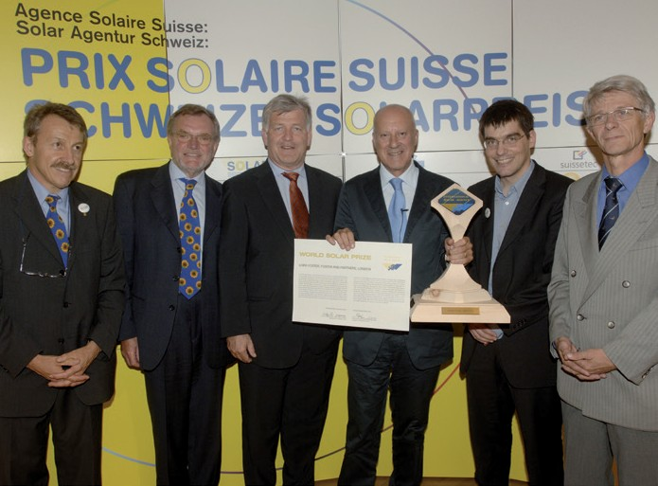
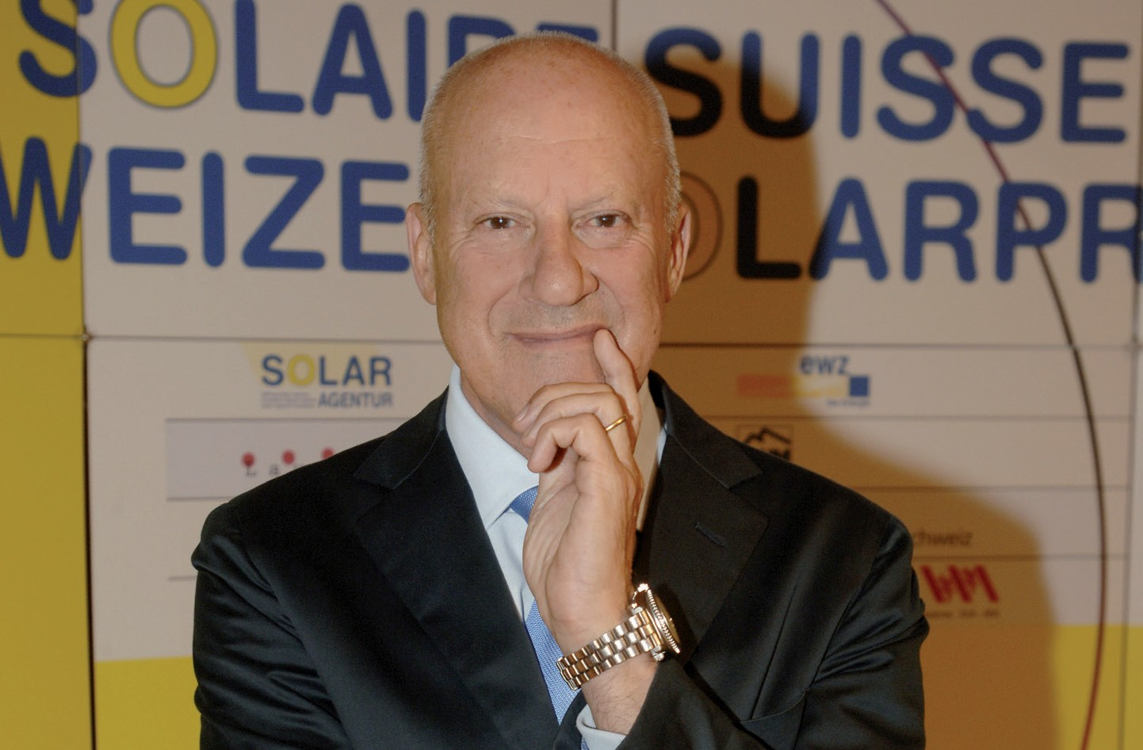2

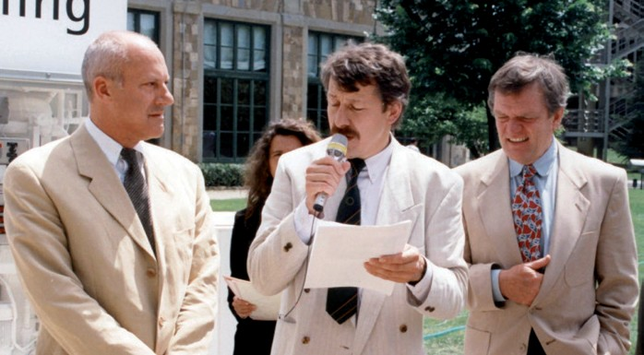
1 3

1 Lord Norman Foster, Foster + Partners, at the Swiss Solar Prize 2010 in Zurich.
2 In 2005, Lord Norman Foster obtained the world solar prize at EPFL in Lausanne.
3 N. Foster, G. Cadonau and W. Palz (from left to right) in 1993 in Florence: Already at that time, Lord Foster was committed to solar architecture, solar cars and renewable energies.

Schweizer Solarpreis 2015 | Prix Solaire Suisse 2015 | 39

